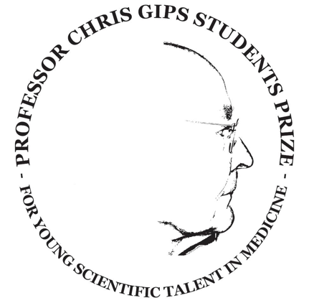
Application form
Professor Chris Gips Student Scholarship

Name:
Project title:
Application date:
Application round: Spring / Fall
Date of birth:
Address:
E-mail:
Mobile phone number:
Bank account:
Dutch medical faculty:
Foreign institution which will be visited:
Department which will be visited:
Supervisor/project leader at Dutch faculty:
Supervisor/project leader at foreign institution:
Full research period: from dd/mm/yyyy through dd/mm/yyyy
Research period in foreign institution: from dd/mm/yyyy through dd/mm/yyyy

In addition to this filled-in form, you are to deliver the following documents in order to make your application complete. Please name the documents starting with the mentioned codes. All documents should be written in English.
A1: Filled in application form (this form)
A2: Filled in budget form
B1: Formal approval for research internship by the accredited committee within the Dutch faculty
B2: Letter of acceptance by the foreign faculty/institute
C1: Project summary (max 1000 words). Include a background, methods, expected outcomes, references, week-by week schedule and the specific goals/added benefits for/of the foreign part of the internship.
C2. Motivational letter (max 300 words)
C3. Curriculum Vitae
Please note that applications lacking any of the documents cannot be taken into consideration. The complete set of application documents should be sent to:

studiefonds@professorchrisgipsfonds.nl

